ENGINEERING TRANSACTIONS • Engng. Trans. • 64, 4, 2014
Polish Academy of Sciences • Institute of Fundamental Technological Research (IPPT PAN)
National Engineering School of Metz (ENIM) • Poznan University of Technology

Instructions for Authors
First AUTHOR¹, Second AUTHOR¹ and Third ONE²
(full name (not only initials) and surname)
¹ Afiliation
Address for correspondence
² Another affiliation (if required)
and address for correspondence
e-mail: AA@domain
corresponding author
The text should be preceded by an abstract (summary) of the paper and list of key words. Abstract: Lorem ipsum dolor sit amet, consectetur adipiscing elit, sed do eiusmod tempor incididunt ut labore et dolore magna aliqua. Ut enim ad minim veniam, quis nostrud exercitation ullamco laboris nisi ut aliquip ex ea commodo consequat. Duis aute irure dolor in reprehenderit in voluptate velit esse cillum dolore eu fugiat nulla pariatur. Excepteur sint occaecat cupidatat non proident, sunt in culpa qui officia deserunt mollit anim id est laborum.
Key words: key word 1, key word 2, key word 3

1. General
We will encourage all the authors to submit the six pages papers after the conference for publication within the framework of a usual peer review procedure in the issue No. 4, vol. 64 of Engineering Transactions. Only the papers delivered as posters or oral presentations can be submitted for publication. The deadline for the paper submission is 15 October 2016.

2. Text (font size, spacing, title, headings, formulas, references)
Times Roman fonts of 11 point size should be used throughout all the paper with single spacing between lines of text. The section title should be centered and written in small capitals (as above). Subsection title should be centered and written in italics (see below).

2.1. Formulas
The formula number consists of two figures: the first represents the section number and the other the formula number in that section. Thus the division into subsections does not influence the numbering of formulae. Only such formulae should be numbered to which the author refers throughout the paper, and also the resulting formulae. The formula number should be written on the left-hand side of the formula; round brackets are necessary to avoid any misunderstanding. Example:
(2.1) $f\left(x\right)=a_{0}+\sum_{n=1}^{∞}{\left(a_{n}\cos{\frac{nπx}{L}}+b_{n}\sin{\frac{nπx}{L}}\right)}$
2.1.1. Notations. All the notations should be written very distinctly. Special care must be taken to write small and capital letters as precisely as possible. It has been established to denote vectors by bold type. Trigonometric functions are denoted by sin, cos, tan and cot, inverse functions – by arc sin, arc cos, arc tan and arc cot; hyperbolic functions are denoted by sh, ch, th and cth, inverse hyperbolic functions – by Arsh, Arch, Arth and Arcth.

2.2. References
Any references should be placed at the end of the paper and referenced in the paper through the number in square brackets, e.g. [1]. Items appearing in the reference list at the end of the manuscript should include the author surname and his/her initials of the first name(s), and then the full title of the paper (in English and in the original language of the paper). In the case of books, the publisher's name, the place and year of publication should be given. The format of sample book and journal references is given at the end of template.

2.2. Figures and tables
Figures, tables and their captions should be centered and numbered (see table 1 and Fig. 1 next page).

Table 1. Sample table.
Sample | Ultimate load [kN] | Diameter of sleeve [mm] | Diameter of cone-shaped body [mm] | Diameter of bolt | Grouting
S 1 | 278.2 | 32 | 32 | 20 | Yes
S 2 | 267.6 | 32 | 32 | 20 | No
S 3 | 272.7 | 32 | 32 | 20 | No
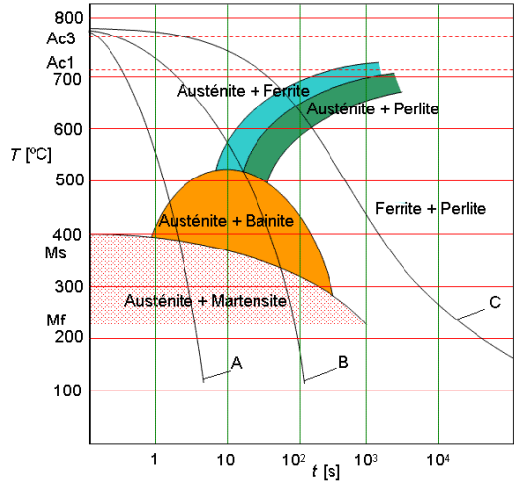
Fig. 1. Sample figure.
Figures should be provided as camera-ready originals (see Fig. 1). The authors are kindly requested to enclose the figures in separate files, in one of the following formats: PostScript or EPS, WMF, EMF, JPG, GIF, PCX, TIFF or BMP with resolution min. 300 DPI – only in final (accepted for publication) version of the article.

References
[1] Timoshenko S., Woinowsky-Krieger S., Theory of Plates and Shells, 2nd ed., McGraw Hill, New York, 122–131, 1991.
[2] Zienkiewicz O.C., Zhu J.Z., A simple error estimator and adaptive procedure for practical engineering analysis, International Journal for Numerical Methods in Engineering, 24(2): 334–357, 1987.

